TECHNICAL ANALYSIS COURSEWORK

*Examining the effectiveness of MACD, RSI 30/70, and Golden Cross trading strategies*

*By Krystof Mincev*

**OBJECTIVES**

Cesari and Cremonini (2003) suggested that technical analysis is the oldest investment appraisal technique used to beat markets. TA allows traders to evaluate the ‘breadth and duration of price trends’, providing evidence for immediate market movements before fundamental analysis (Doug Standefer, June 2003). It makes one assumption: past events are probable to re-occur in the future.

In this report three basic (RSI, MACD, and Golden Cross), as well as one complex (MACD and RSI), trading strategies, reliant upon TA, shall be examined. The report utilises Boyd Gaming Corporation stock data, a company trading on the NYSE, generated from yahoo.finance.com. The data ranges from 01.01.10 – 31.10.14, and shall be divided into three subgroups. The overarching aim is to determine the most profitable trading strategy, and evaluate if it outperforms a simple buy-and-hold trading strategy.

**TRADING ENVIRONMENT**

*Margin requirement:*

‘Interactive Brokers’ require a minimum initial margin of 25%*(Stock Value)/ 30%*(Stock Value), and an equal maintenance margin, for long/short positions Since this is in line with regulatory requirements, throughout this report we shall assume these margin requirements.

*Transaction costs:*

‘Interactive Brokers’ charges $0.58 per 100 share US equity purchase, for NYSE. A more conservative figure of 0.02% per transaction shall be assumed.

*Margin rate/ Interest charged:*

A comparison of margin rates charged by 14 brokers in November 2013, highlights that the industry rates ranged around 6%. Although, ‘Interactive Brokers’ currently charge 1.6% upon the first $100k borrowed, we assume a more conservative fixed margin rate of 6% throughout this report.

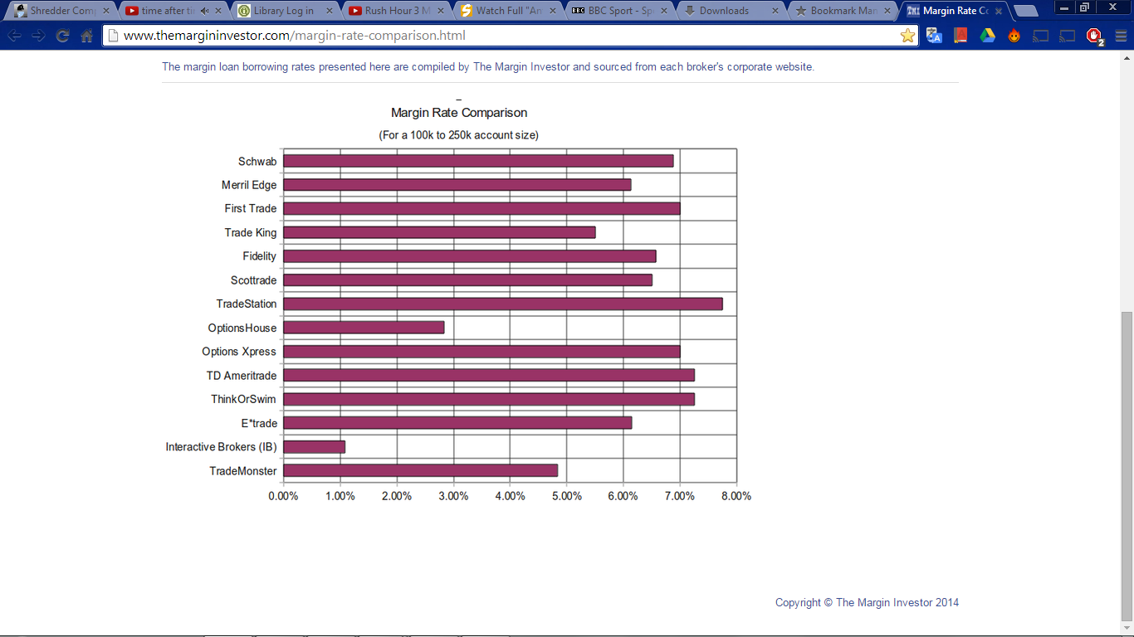

*(The Margin Investor, November 2013)*

*Money market rate/Interest received:*

‘Interactive Brokers’ pays 0% interest on credit cash deposits, and an equal rate on short sale cash proceeds. We assume a 0% interest payment (received).

*Trade Execution:*

‘Interactive Brokers’ provides instantaneous access to markets for US equities trading on the NYSE. We shall assume no delay in the execution of trade orders.

*Equity:*

An initial equity size of $1000000 is assumed; however, a restriction of 90% is placed on equity exposure.

*Stop Loss:*

Thomas N. Bulkowski (2013) found that although both an initial stop and trailing stop loss decreased the maximum loss experienced during trading, they hurt the overall performance of a RSI trading strategy; trades were stopped out before significant returns could be achieved. Consequently, no stop loss shall be set throughout this report; we wish to preserve the same trading environment for all strategies.

([Thomas Bulkowski’s](http://thepatternsite.com/about.html), 2013)

**TECHNICAL ANALYSIS:**

**GOLDEN CROSS**

The ‘Golden Cross’ typically refers to trading strategy implementing the intersection between a 50 day Moving Average and a 200 day MA. In our analysis, we encapsulate a range of MA lengths under this heading, attempting to find the true golden cross. To calculate the MA use the following equation:

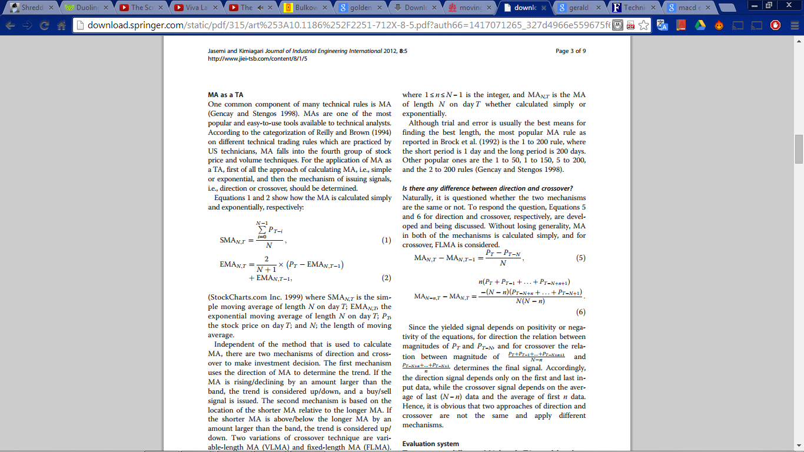 (Jasemi and Kimiagari, 2012, page 3)

N = period length (N successive daily closing prices), T = time period.

Through an example, the calculation of MA5 involves taking five recent successive security prices, summing them, and dividing by five; this is a simple moving average. Although, ETFHQ, in an article entitled ‘Golden Cross - Which is better’, argues exponential MAs outperform simple MAs by ‘by well over a percentage point on average’ (ETFHQ, 2013), we shall concentrate on the simple MA.

(http://etfhq.com/blog/2013/01/15/golden-cross-which-is-the-best/) (Forbes, 2013)

A buy/sell signal (long/short) shall be interpreted to occur when the ‘short’ MA crosses the ‘long’ MA from bellow/above. We assume a band length (difference required to implement trade) of zero (fixed length MA). A Forbes article (4/15/2013) found a MA (50,200) strategy generated an annualized return of 1.54% from 2009, with 58% trade efficiency.

(Forbes, 2013)

*Training Set Optimization (04.01.10 - 02.01.13):*

Using ‘MetaStocks System Tester’ two tests were run on the BYD data from (04.01.10 - 02.01.13). The lengths of the SMA (N1) and the LMA (N2) were varied (N1 from 1-50, N2 from 20-200) to find the optimum crossover length; the results were judged by their % gains, with the optimal cross length boasting the highest % return (use throughout report). Below the 20 most profitable crosses are plotted. A detailed summary of the 10 most profitable strategies is presented:

**10 Most Profitable Crossovers**



*Note: above all % gains represent total returns; this shall apply throughout this report within tables.

The analysis suggests the optimal/golden cross occurs when a 1 day MA crosses a 50 day MA. The MA(1,50) strategy yielded an annualized return of 2.03%, outperforming a buy-and-hold strategy by 2.37%. Additionally the strategy had an average total trade efficiency of 2.02%, and a reward/risk index value of 100%.

**MACD**

The Moving Average Convergence Divergence was proposed in 1979 by Gerald Appel. The MACD can unambiguously account for both momentum and trend within security movements, and is highly correlated to its underlying security. To calculate the MACD a difference between the short term (N1) moving average and the long term (N2) moving average of a security’s prices is taken: N1 < N2. The MACD fluctuates around 0 (when MAN1=MAN2); positive values (positive divergence) signify bullish momentum, and negative values signify bearish momentum.

The MACD shall be implemented as part of a moving average crossover trading strategy. A buy/sell signal shall be interpreted as a cross by the MACD, of its signal line (the Nk day simple MA of the MACD), from underneath/above. The value of Nk shall be varied, and optimized.

(Trading stocks with MACD, Bhandari and Bramesh, December 2011) (Forbes, 2013)

Research by Huang, and Kim (2006) found that trading strategies implementing the MACD outperformed a buy-and-hold strategy, for the DJIA (1983-2006). Chong and Ng (2008) discovered that a MACD strategy outperformed a buy-and-hold strategy from July 1935 to January 1994 for the FT30. Finally, a Forbes article (4/15/2013) found a MACD strategy generated annualized returns of 1.85% with 59% trade efficiency.

(A test of MACD trading strategy, Bill Huang & Yong Soo Kim, 2006) (Forbes, 2013) (Revisiting the performance of MACD and RSI oscillators, June 2014)

*Training Set Optimization (04.01.10 - 02.01.13):*

The lengths of the MACD signal (length of MACD MA) were varied from 5-50 in order to find the optimum signal length. Below the 20 most profitable signal lengths are plotted. A summary of the 10 most profitable strategies is presented:

**10 Most Profitable Signal Lengths**



The optimal signal length is 27 days, yielding an annualized return of 2.51%; 2.8% higher than a buy-and-hold strategy. The strategy had an average total trade efficiency of 19.2%, a reward/risk index of 99.9%, and an average holding period of 25 periods.

**RSI**

The Relative Strength Index was proposed in 1978 by J. Welles Wilder. It is an oscillator index, ranging from 1 to 100, that has been implemented in numerous trading strategies. Values above/bellow 50 are termed as representing a bull/bear market. The RSI is associated with a 30/70 trading strategy: a RSI value of 70 represents an overbought level (unsustainably high prices) within the market, implying an opportunity to short, whilst the reverse applies for a value of 30 (unsustainably low prices). Calculating RSI use:

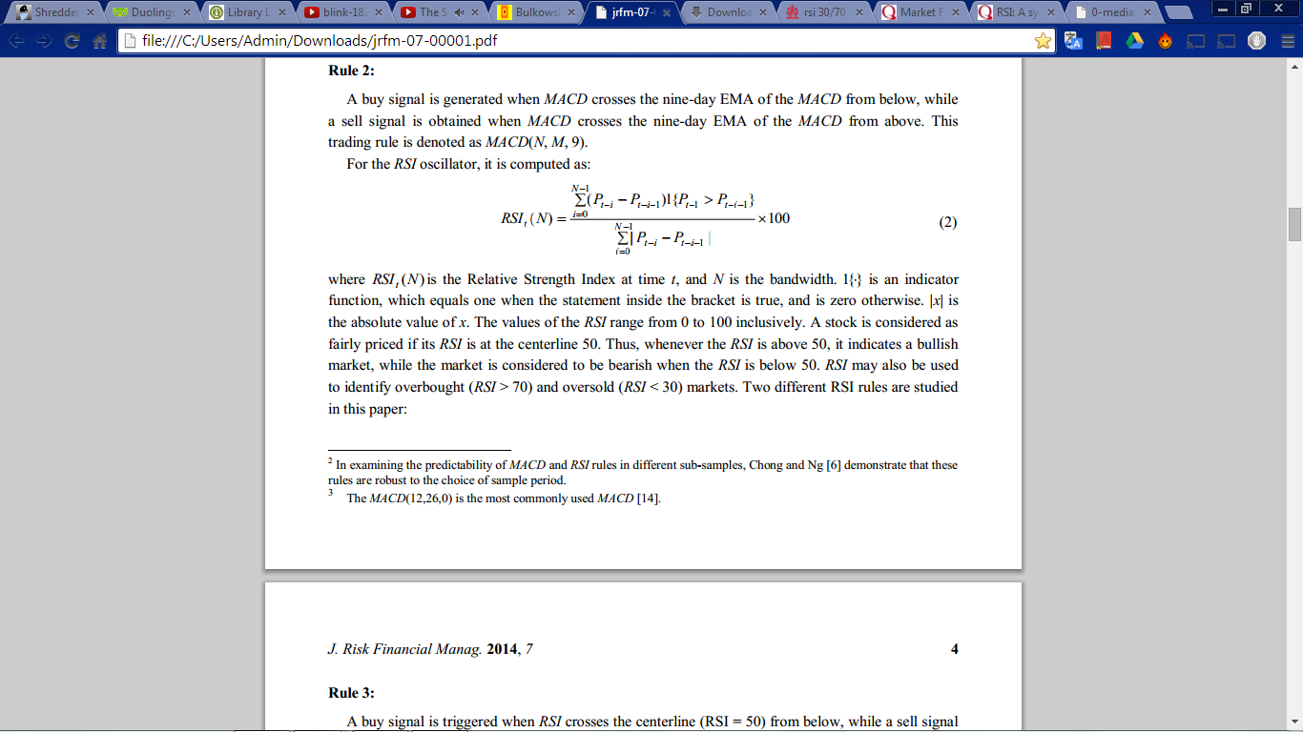  
(Revisiting the performance of MACD and RSI oscillators, June 2014, page 3)

(Doug Standefer, June 2003)

Where: Pk = price of the security at time k, N = the number of lags of price changes, and 1{.} = an indicator function (equals 1 for a price increases, and 0 for a price decreases).

The index increases/decreased when security prices rise/fall; a value of 100/0 would account for N consecutive price increases/decreases. We shall implement the 30/70 strategy, varying the number of time periods (N) used in the RSI calculation.

([Thomas Bulkowski’s](http://thepatternsite.com/about.html), 2013) (Doug Standefer, June 2003) (Revisiting the performance of MACD and RSI oscillators, June 2014)

Chong and Ng (2008) determined that a trading strategy implementing the RSI for the FT30 index significantly outperformed a buy-and-hold strategy (1935-1994). Chong, Ng, Liew (2014) reaffirmed this for the DJIA (1976-2002), whist Thomas N. Bulkowski’s (2013) determined the RSI outperformed the S&P in 68% of cases (1990-2008). A Forbes article (4/15/2013) found that the 30/70 RSI trading strategy averaged annual returns of 2.37% from 2009, with 57% trade efficiency.

([Thomas Bulkowski’s](http://thepatternsite.com/about.html), 2013) (Forbes, 2013) (Revisiting the performance of MACD and RSI oscillators, June 2014) (Forbes, 2013)

*Training Set Optimization (04.01.10 - 02.01.13):*

The lengths of the RSI (periods used in calculating RSI) were varied from 5-25. Below the 20 most profitable RSI lengths are plotted. A detailed summary of the 10 most profitable strategies is presented:

**10 Most Profitable RSI Lengths**



The optimal RSI length is 22 periods, yielding an annualized return of 1.67%; 1.91% higher than a buy-and-hold strategy. The strategy had an average total trade efficiency of 51.12%, a reward/risk index of 90.2%, and an average holding period of 136.

**COMPLEX STRATEGY – RSI 30/70 & MACD**

We combine our MACD trading strategy with our RSI 30/70 strategy. The strategy functions by combining the buy and sell signals of the MACD and RSI, only exercising a security purchase/sale when the MACD crosses its signal line form bellow/above, whilst concurrently the RSI is below/above 30/70. The Golden Cross is excluded, as the MACD incorporates the strategy and allows for more prompt purchases/sales.

*Training Set Optimization (04.01.10 - 02.01.13):*

Both the MACD signal length, and RSI length are varied from 4-49. Bellow the table of the 10 most profitable combinations is presented:



All strategies provided equal % gains. We choose (29,7) as the optimized combination; it generates an annualized return of 2.61%, outperforming the market by 2.85%. The strategy generates an average total trade efficiency of 72.52 %, as well as a profit/loss index value of 98.16 %.

**CHOSSING THE MOST PROFITABLE TRADING STRATEGY**

*Test Set (02.01.13 - 31.12.13):*

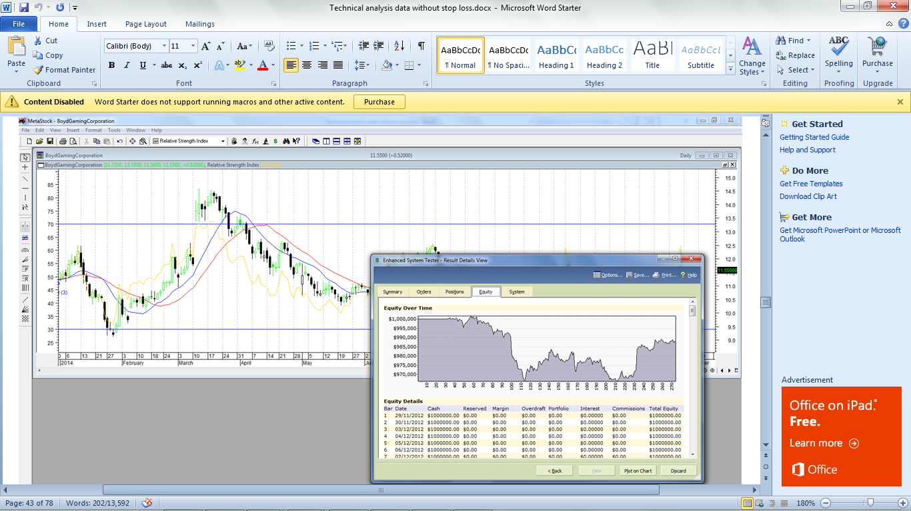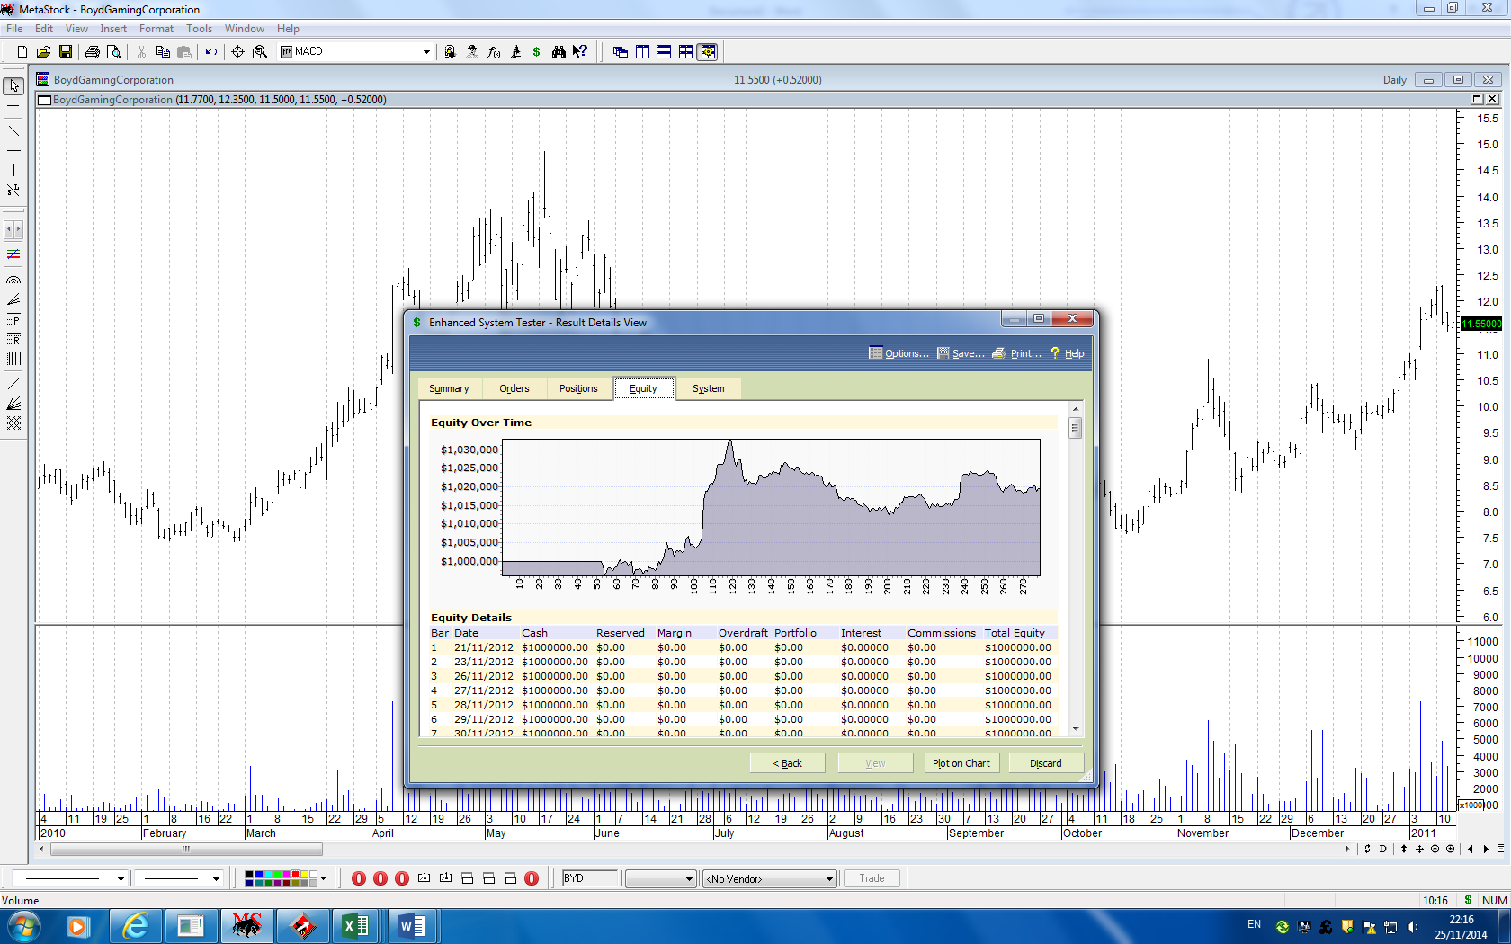*Equity Over Time:*

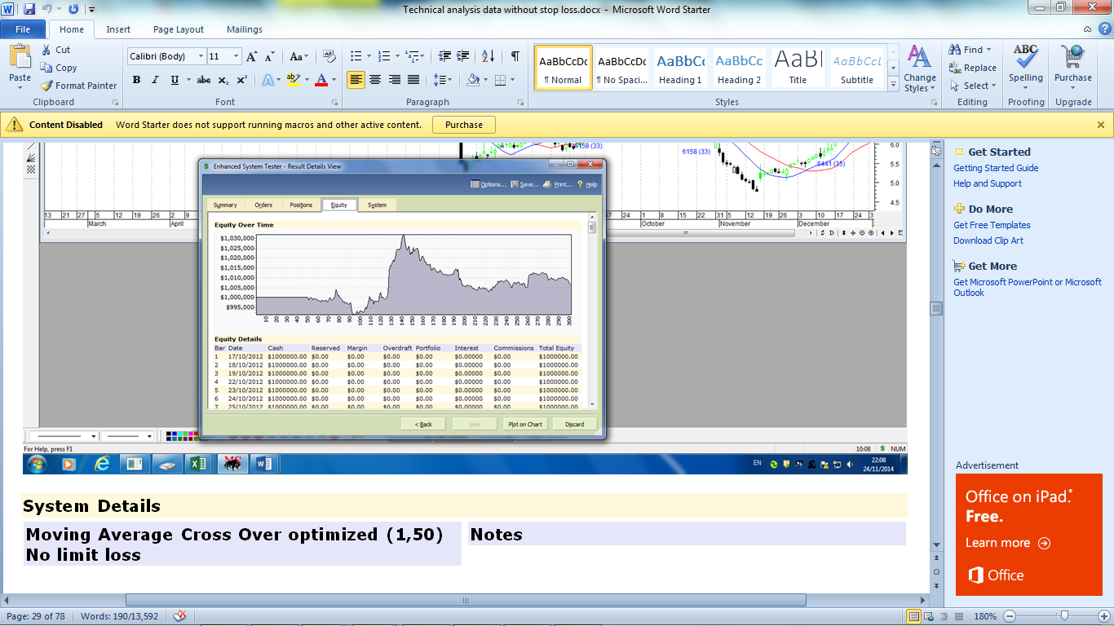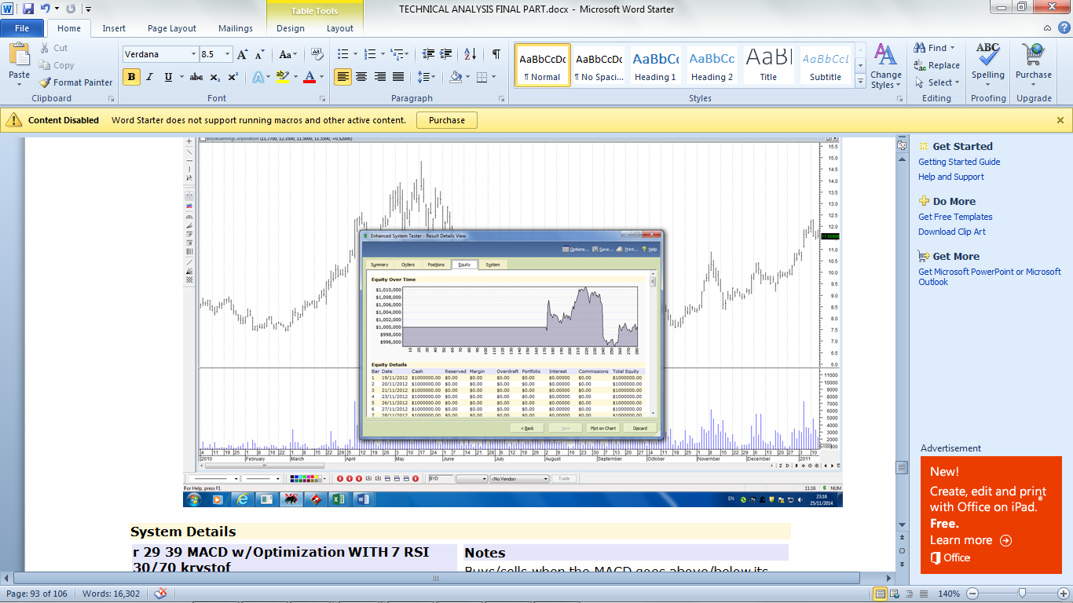

Note: Top left RSI(22), top right MACD(27), bottom left MA(1,50), bottom right RSI(7) & MACD(29)



The MACD(27) is the best trading strategy. As well as providing an annualized return closest to its return in the training set, the MACD(27) provided the highest overall return, along with the highest profitability ratio (profit/loss index), and did not suffer from trade execution problems (COMPLEX(29,7) strategy only induced one trade). Moreover, the MACD(27) significantly outperformed its counterparts with respect to the risk/reward index. The risk/reward measures the level of risk assumed for a given return. A value of 100% implies that a significant return is generated without any risk; the MACD(27) had a value of 83.26%.

Nevertheless, the MACD(27) significantly underperformed a simple buy-and hold strategy (returned 4.01%). Additionally, the equity over time graph for the MACD(27) does not rise gradually, implying inconsistent profits. Finally, the average total trade efficiency figure is negative; the ‘percentage of total possible profits realized’ was negative (MetaStock User Manual, 523). Hence, although the MACD(27) is recommended to subsequently be used upon our real data, perhaps a combined strategy involving the MACD and fundamental analysis should be used instead.

(Meta Stock User Manual, 536)

**REAL DATA**

*Evaluating the performance of the MACD(27) from (20.11.13 - 31.10.14):*

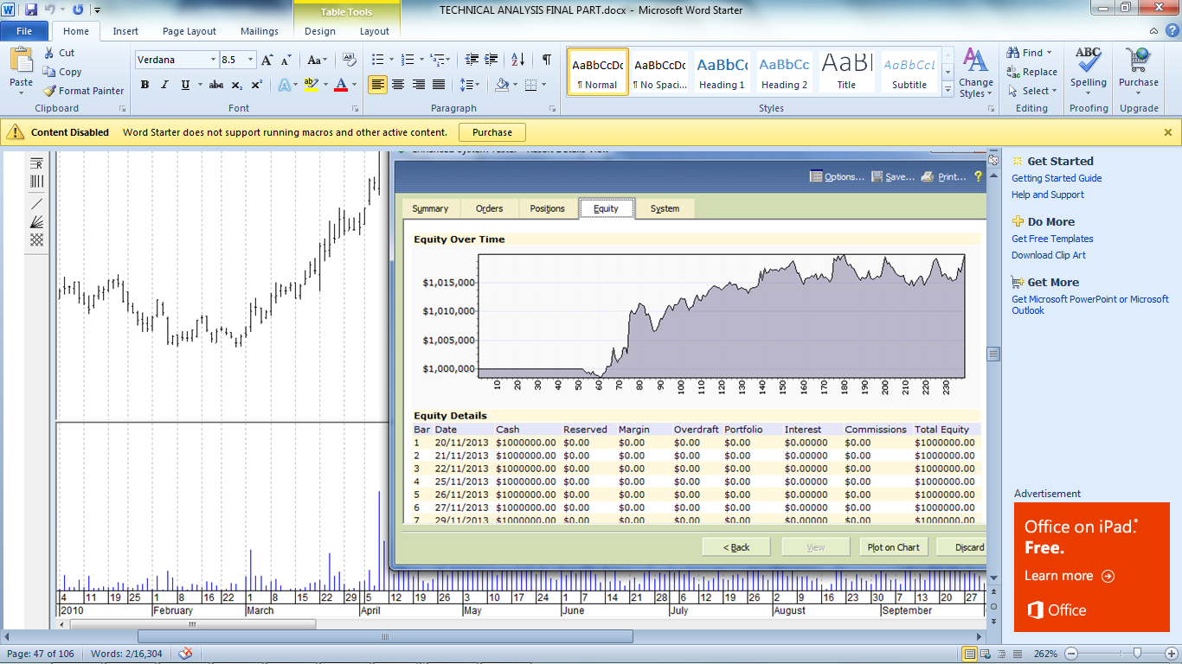



The MACD(27) generated an annualized return of 2.1%; outperforming a buy-and-hold trading strategy by 2.34%. Comparing this return with returns from previous periods, we conclude that the MACD(27) was consistent in generating positive returns; 2.1% ± 0.5%. Overall investors implementing a MACD(27) strategy from (2010-2014) would have outperformed a buy-and-hold strategy by roughly 1.25%.

For the real data MACD(27) managed to fairly consistently predict profits (equity graph) and capitalized on 22.28% of the total potential returns (trade efficiency). Concluding the MACD(27) generated significant returns without a high risk exposure (reward/risk index equalled 92.78%), and had a significantly high success rate (profit/loss index equalled 86.32%).

**CONCLUSION**

The objective of this report was to find a trading strategy which would outperform a simple buy-and-hold trading strategy. The MACD(27) was unable to outperform this strategy in 2013; however, overall an investor implementing MACD(27) would have succeeded in our aim; 2013 appears to have been a significantly bullish year, unlikely to repeat itself.

Further research should be conducted upon the MACD, examining its performance over a range of securities, as well as markets. Currently, we cannot justify utilizing MACD(27) in conjunction with any other company than Boyd Gaming Corporation.

Referencing:

*Online:*

Boyd Gaming Corporation stock data generated from yahoo.finance.com

(Meta Stock User Manual, accessed [online]: <http://www.moneymentor.com/TradingSoftware/MetaStockUserManual.pdf>, 28.11.2014)

(The Margin Investor, November 2013, accessed [online] <http://www.themargininvestor.com/margin-rate-comparison.html>, 28.11.2014)

##### (Forbes, 4/15/2013, accessed [online] <http://www.forbes.com/sites/greatspeculations/2013/04/15/technical-analysis-indicator-that-works-turns-positive-for-these-stocks/>, 28.11.2014)

##### (ETF HQ , accessed [online]

##### <http://etfhq.com/blog/2013/01/15/golden-cross-which-is-the-best/>, 28.11.2014)

##### (The Patter Site, [Thomas Bulkowski’s](http://thepatternsite.com/about.html), 2013, accessed [online] <http://thepatternsite.com/RSI.html>, 28.11.2014)

*Dissertations and Articles:*

(A test of MACD trading strategy, Bill Huang & Yong Soo Kim, 2006)

(Journal of Industrial Engineering International, Jasemi and Kimiagari, 2012)

(Trading stocks with MACD, Bhandari and Bramesh,December 2011)

(Market forces: technically speaking…, Doug Standefer, June 2003)

(Revisiting the performance of MACD and RSI oscillators, Terence Tai-Leung Chong, Wing-Kam Ng, and Venus Khim-Sen Liew, February 2014)